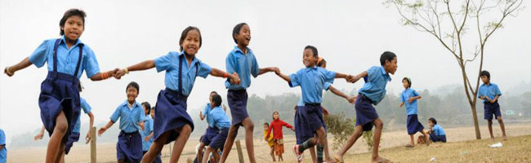
Lingaya’s Lalita Devi Institute of Management & Sciences
Mandi Road, Mandi, New Delhi-110047

Department of Education

DPSE

Activity report
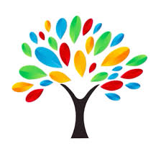
(July,2021-March,2022)

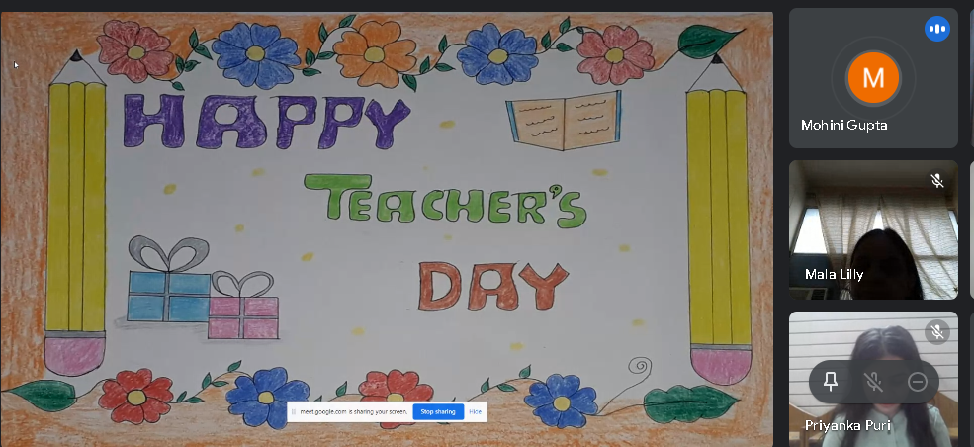
INDEPENDENCE DAY CELEBRATION
Independence Day was celebrated on 14th August,2021 organized by Department of Education, Lingaya’s Lalita Devi Institute of Management & Sciences. Multiple competitions were organized for students who participated with full enthusiasm and gusto. The students participated in English/Hindi Poem, English/Hindi Speech, Patriotic Hindi song, and poster making activities. Students had a thorough discussion among them and performed well in each and every activity.
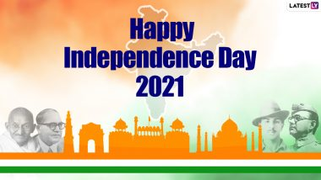
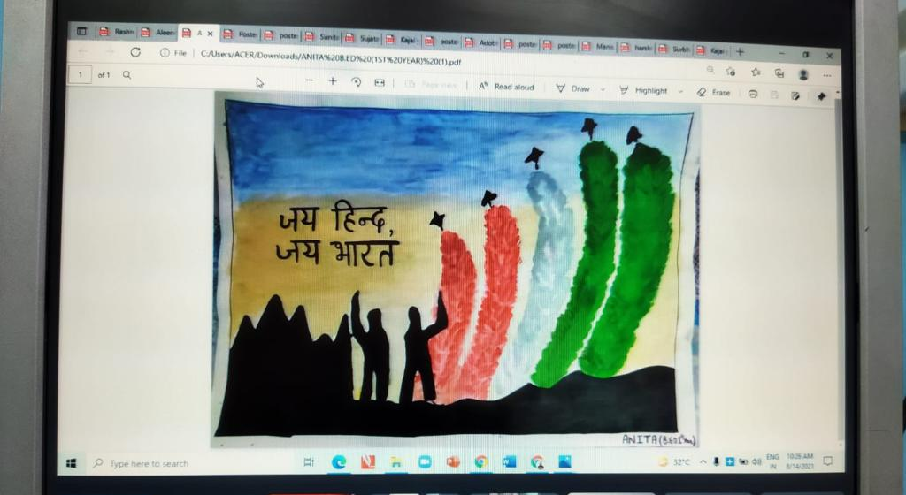

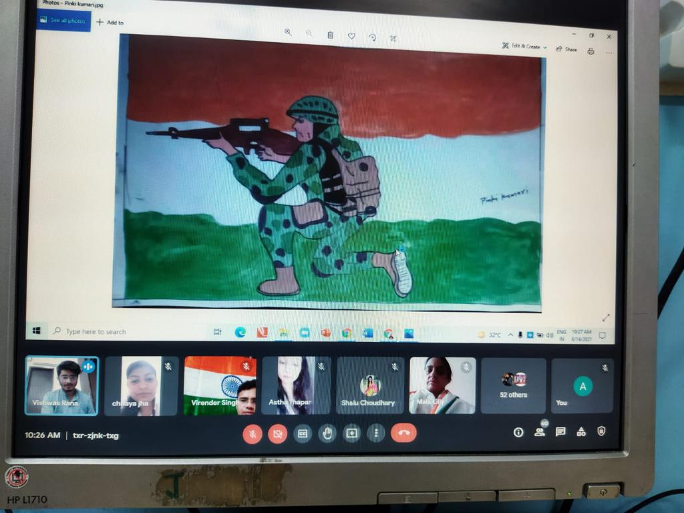
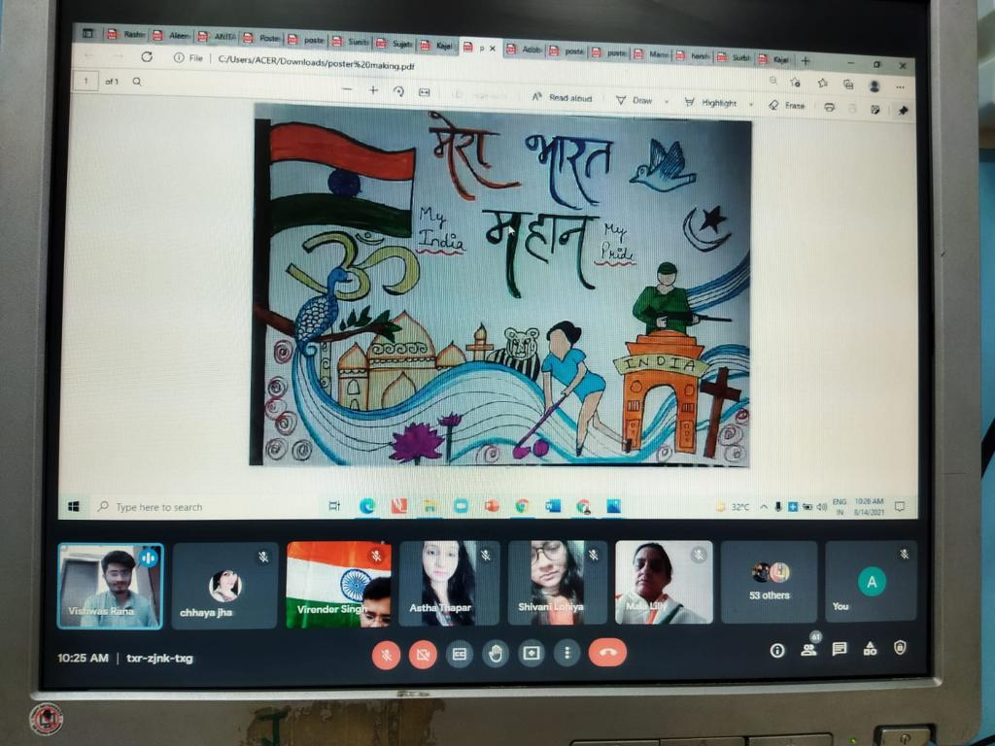

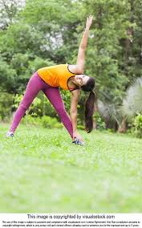
Workshop on Yoga & Meditation
A Workshop on Yoga & Meditation was organized for students of DPSE on 25th August, 2021 in online mode. A range of yoga asanas were done by the students. Students participated wholeheartedly and actively. Not only the students enjoyedbutalsolearnttheimportanceofyoga and the importance ofmaintaininga healthy body was emphasized.

Hindi Diwas celebration
Being one of the most diverse nations in the world, India is a place where numerous traditions, customs, religions and languages flourish. And among all the languages, Hindi is considered the chief as well as the widely spoken in India.
Hindi got an exalted status in India on September 14, 1949, when it was adopted as the official language of the country. Since, then September 14 is celebrated as Hindi Diwas to pay tribute to the official language of India.
On this occasion, DPSE dept., LLDIMS virtually organized a speech activity to mark the importance of our national language. Students shared their write-ups about the language. Their write-ups reminded us of a few interesting facts related to Hindi language. Also, highlighted the significance of the language in connecting the citizens of India. The students shared that this rich language is the base of many words in other languages too. It was further added that Hindi is one of the oldest and the most influential languages in the world and we should take pride in speaking our mother tongue.
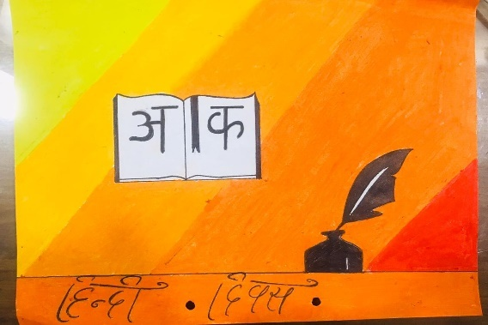
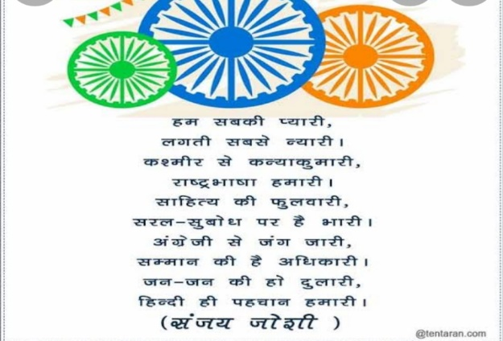

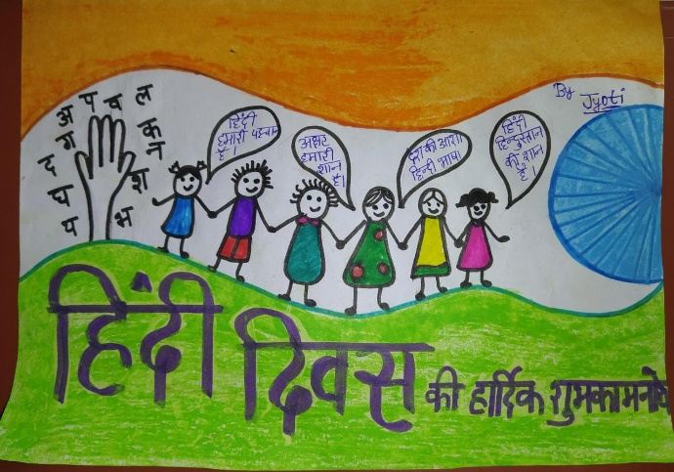

Teachers’ Day Celebration
On the occasion of Teacher’s Day, a short celebration held on 6th September, 2021 through online modein which students of DPSE Department performed few activities and showed a token of respect for their teachers.
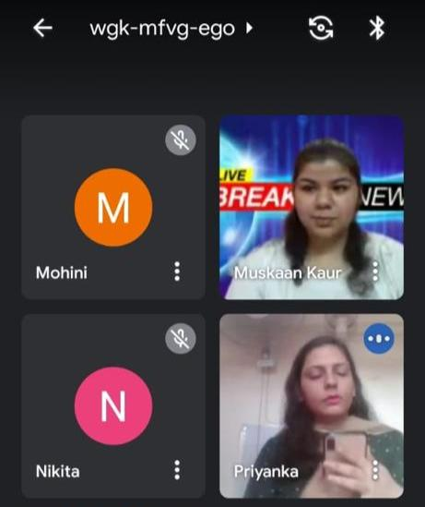
The event began with aspeech and was followed by poem, singing, drama, and posters. The event was a great success and was appreciated by all the teachers.
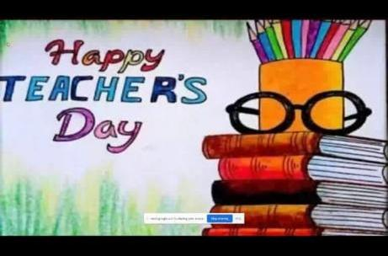
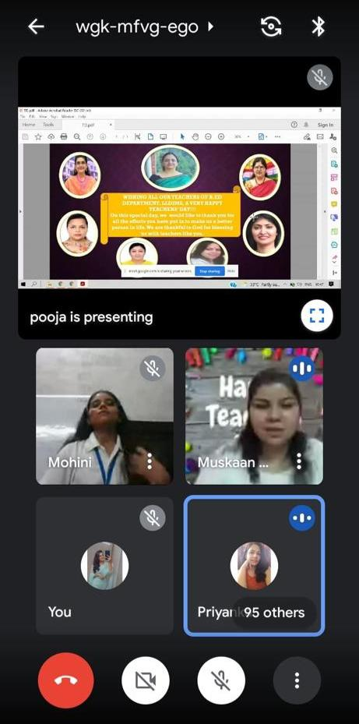

Workshop on Teaching Skills
GUEST LECTURE ON THE TOPIC- MICRO TEACHING
Dr. Pravesh Lata , the resource person gave the guest Lecture on the topic- “Micro Teaching” on 9th March, 2021.
Dr. Pravesh Lata explained that Micro teaching, a teacher training technique currently practiced worldwide, provides teachers an opportunity to perk up their teaching skills by improving the various simple tasks called Teaching Skills. With proven success among the novice and seniors, microteaching helps to promote real- time teaching experiences.
The core skills of microteaching such as presentation and reinforcement skillsindeed made familiar with a new meaning of education which was completely different from their existingnotion. It is undeniably not the mere accumulation of degrees but a person’s understanding of how and whereto use his knowledge judiciously. ‘Can we really count ourselves as Educated?’ left the students to introspectamong themselves. When we are able to positively affect someone’s life even in the slightest way would makeuscalla Humane Citizenora Humane Teacher.

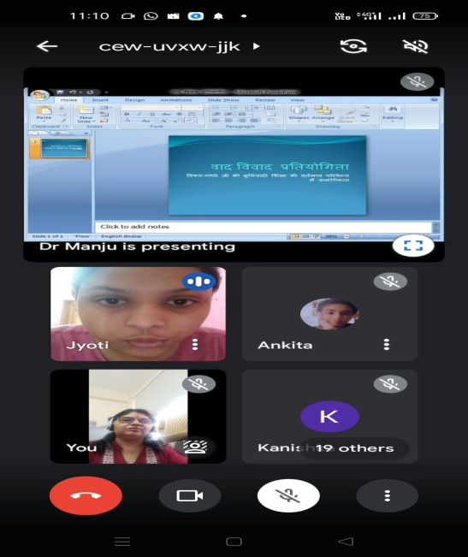
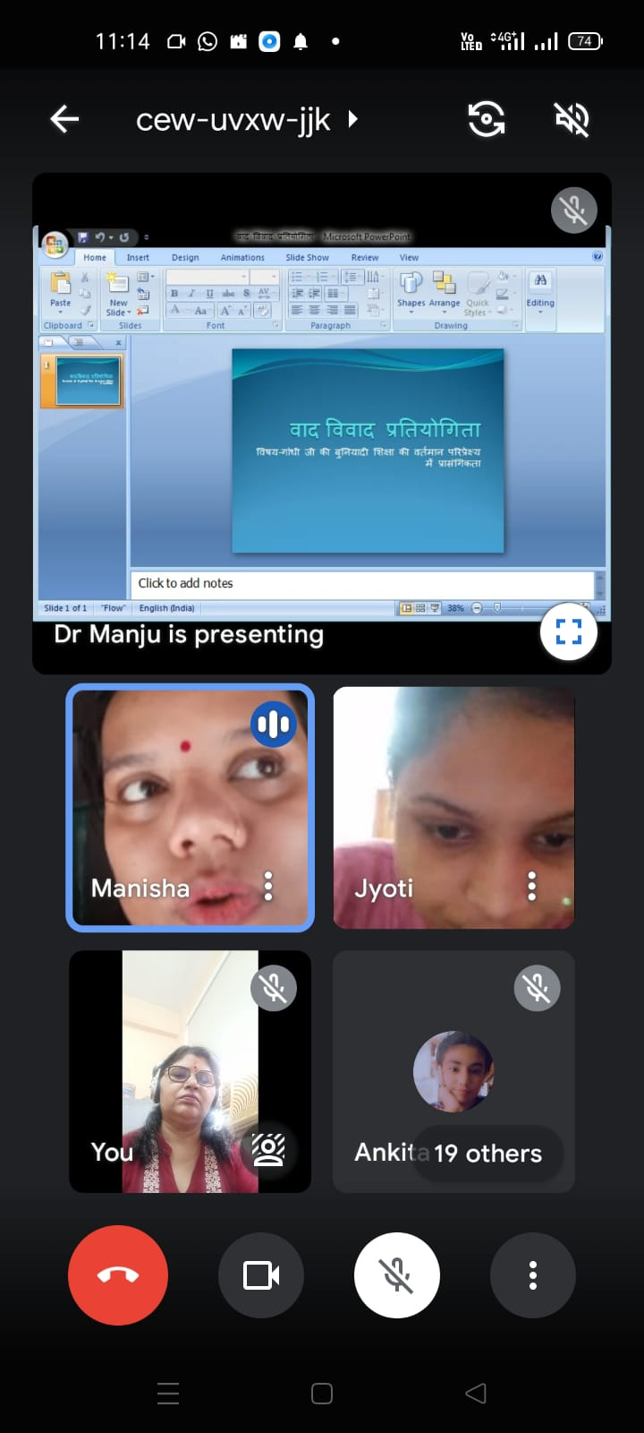

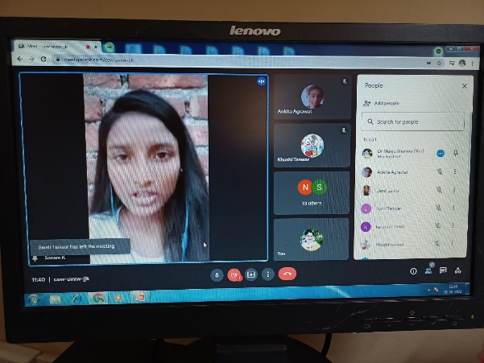
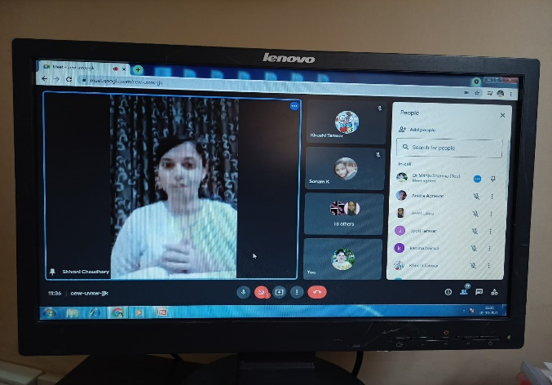

Christmas Day Celebration

Christmas is the festival which inspires the spirit of sharing and caring. Soaking in the spirit of the Christmas department of Education, LLDIMS celebrated the festival with enthusiasm on 24thDecember, 2021. Everybody was dressed in
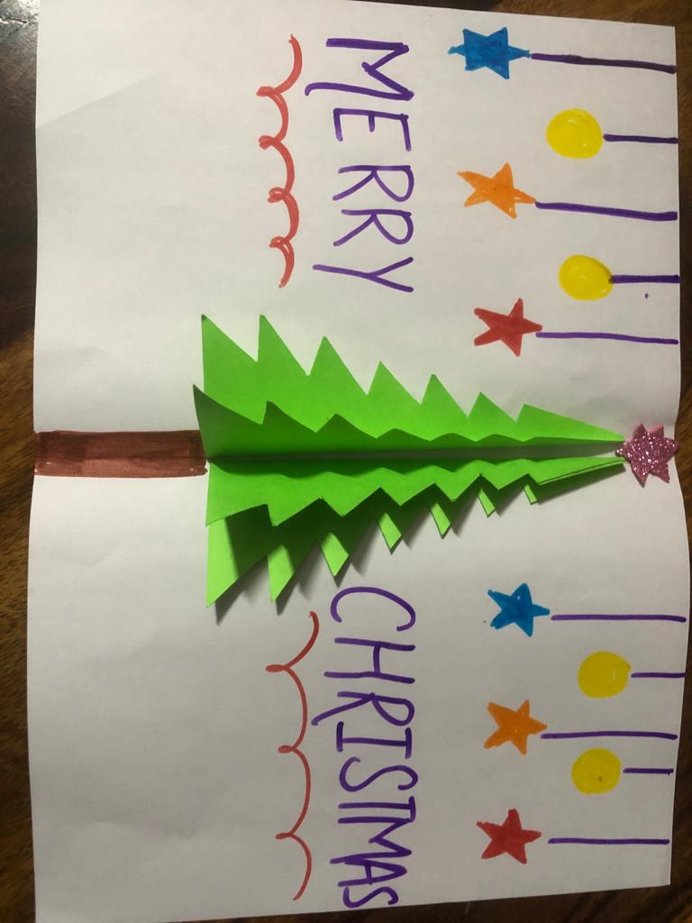
Red and white (Santa’s favourite colours). The students sang melodious carols and danced beautifully to wish their teachers and classmates.
The significance of the festival was explained to the students through the Christmas story.
To inculcate the spirit of sharing the students distributed a small Christmas gift to all the didi’s and bhaiya’s at their homes. The boundless joy of celebrating the festival was visible on the faces of all
the children.
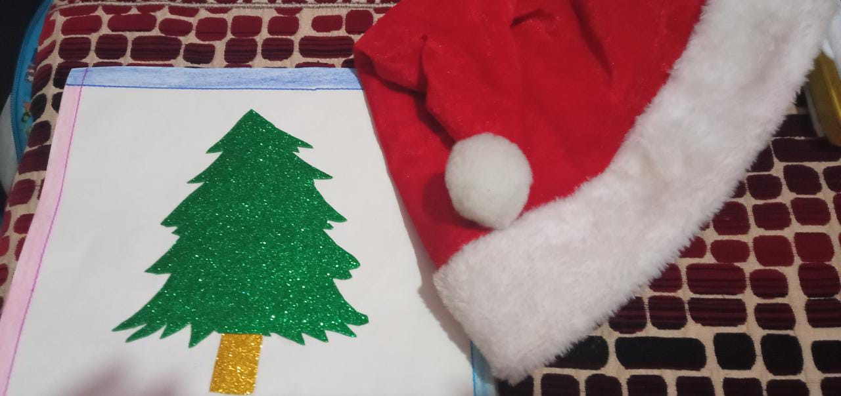
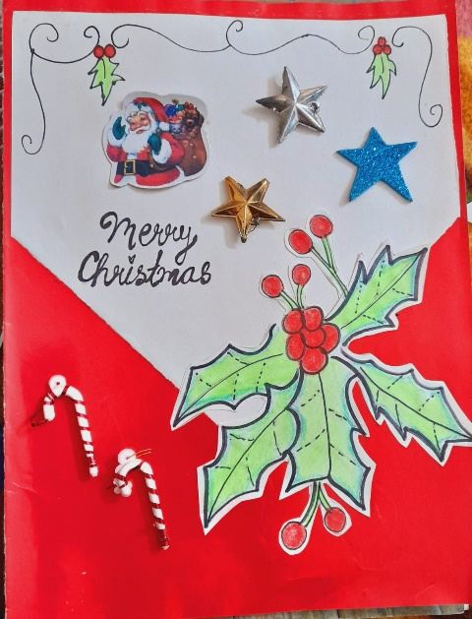
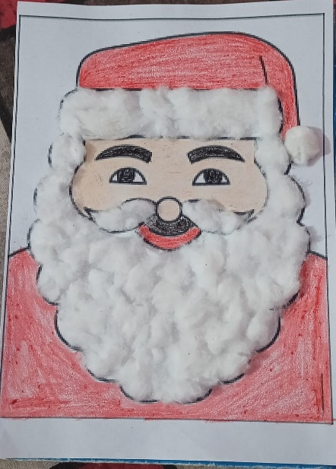

New Year Celebration
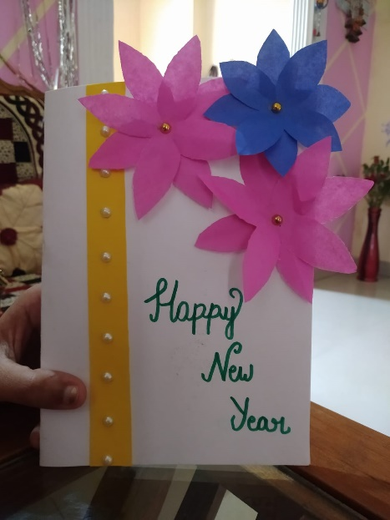
On the occasion of New Year, a short celebration held on 2nd January, 2022 through online mode in which students of DPSE Department performed few activities and showed a token of respect for their teachers.
The event began with a speech and was followed by poem, singing, drama, and posters. The event was a great success and was appreciated by all the teachers.
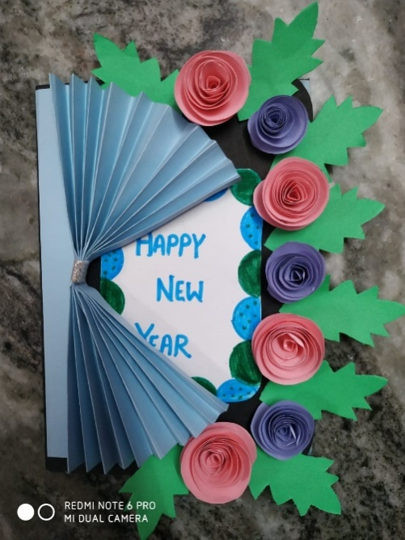
Students shared their new year resolutions along with their strategies to implement their goals. Overall, it was a nice get together and both the students prepared hand-made cards also. The cards were really beautiful and appreciated by all.

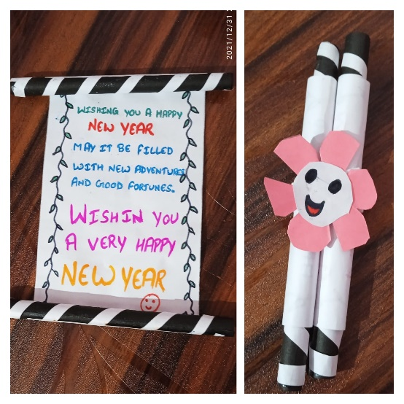

Republic Day Celebrations

On 26th January 2022, Virtual Republic Day celebration was organized by Ms. Arshiya Rai (Assistant professor). The celebration started at 10:00 am with flag hoisting and national anthem.After the speech, Kajal Pandey recited a beautiful poem (in Hindi) titled ‘26 JANUARY 1950 KI KAHANI’. After the dance performance, Tanvi recited a poem (in English) titled ‘LET’S CELEBRATE’ which was composed by Ritu Mishra. After that, Shweta Rajindra sang a song ‘TERI MITTI’ in her soulful voice. Then all the students and faculty members took a pledge and everyone stood up for the national anthem. Ms. Arshiya Rai congratulated everyone for being a part of the celebration of such an auspicious day and appreciated the students for their participation and efforts.

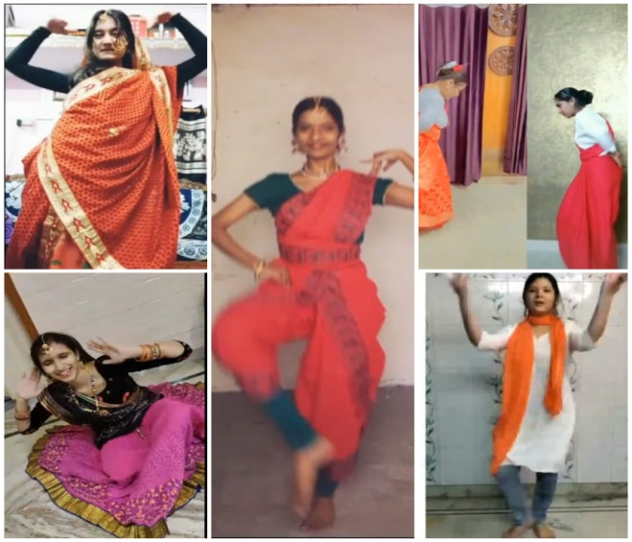
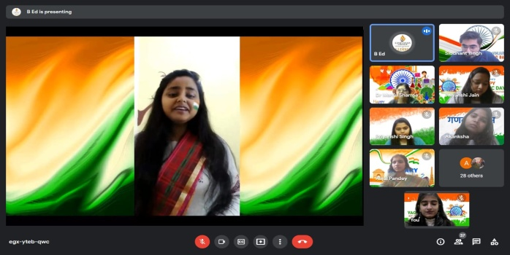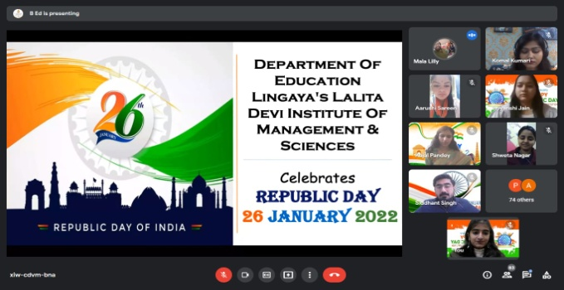

Workshop On Life Skill
Department of education, LLDIMS organized a workshop on life skills demonstrated through role plays under the supervision of Ms. Arshiya Rai (Assistant Professor), on 9th April 2022 in the college seminar hall, 12:00 p.m onwards. Ms. Arshiya Rai welcomed everyone and gave an introduction of the workshop to all the students present there.
After the role play of every group, Ms. Arshiya Rai asked questions related to the inculcation of life skills through the role play which were to be answered by the group members. At the end, Ms. Arshiya Rai appreciated the efforts and hard work of all the participants and gave a vote of thanks.

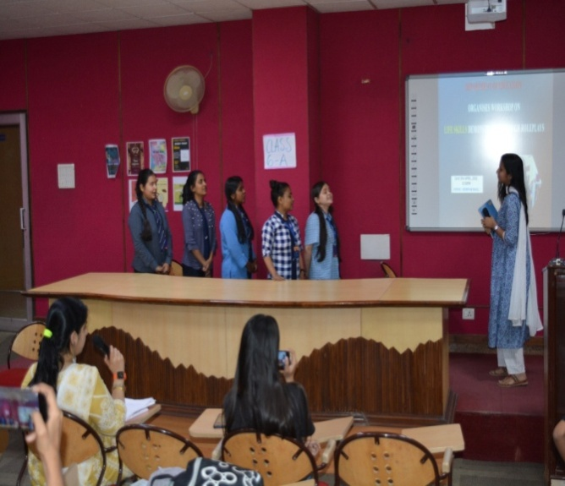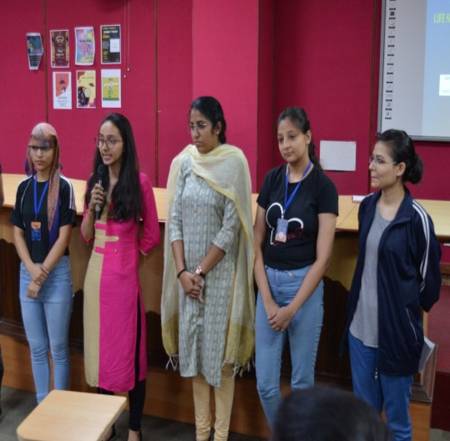

E-WORKSHOP ON:

“LISTENING SKILLS & BRAINSTORMING “

“TIME & STRESS MANAGEMENT”

BY NATIONAL COMMISSION OF WOMEN, DELHI
Lingaya’s Lalita Devi Institute of Management and Sciences, in collaboration with National Commission for Women, Delhi organized a workshop on Personal Capacity Building. The meeting was held for all female students from first to final year across all courses. The meeting had a strength of over 200+ female students and at the beginning itself, the students were briefed about the three aspects that were to be elaborately covered in the workshop.
The three aspects were as follows: -
- Listening Skills and Brainstorming.
- Time Management and Stress Management.
- Internal Communication and Group Discussion.
Out of these three aspects, Dr. Manju Sharma explicated upon “Listening Skills and Brainstorming”, which was followed by Dr. Sangeet Sharma covering “Time Management and Stress Management.” Additionally, there was a brief mention about the Women’s Cell of LLDIMS, which was installed in 2010. Students were made familiar with the objective of the E-Workshop- the welfare of all females.
As the workshop marked its onset, Dr. Manju Sharma kickstarted the event by laying due emphasis upon the vitality of good communication skills that aid an individual in seeking employment, sitting for placement interviews, and in fostering good interpersonal relations with others. She validated how a person should eloquently express his or her viewpoints and ideas coherently and how one can strive to become an effective listener, in turn. With the help of an informative PowerPoint Presentation and pictorial representation in the form of diagrams, she figuratively linked the significance of a bulb and a brain (how, due to the flowing of electric currents, the bulb remains lighted. Similarly, due to the free-flowing of ideas, pupils’ brains get ignited with a spark, and their original and creative ideas help in shaping their cognitive capacities.) Dr. Manju Sharma further elaborated upon body language, speaking techniques, good organizational skills, mind mapping, and paraphrasing. She made her interaction interesting through various illustrations and by encouraging participation.
Next in line was Dr. Sangeet Sharma who initiated “stress management” by conducting a LIVE demonstrative exercise in which he asked the attendees to sit straight, lift their eyes a little, and give a big smile. The purpose of this exercise was to explain to the students the pattern in which stress adversely affects bodily postures, eating habits, mental abilities, etc. A lot of students took interest and asked him various questions, to which he promptly responded. He compared the journey of life to a Radio FM Station to describe that life is a journey and not an end process. He explained how certain concepts are closely intertwined: feeling-action-behavior-result. Then, he moved on to “time management”, which is essentially self-management. Dr. Sangeet Sharma articulated the impediments that come in the way of self-management, like procrastination- one’s biggest foe and not prioritizing important tasks. Overall, his session was quite interactive marked by the keen participation of students.
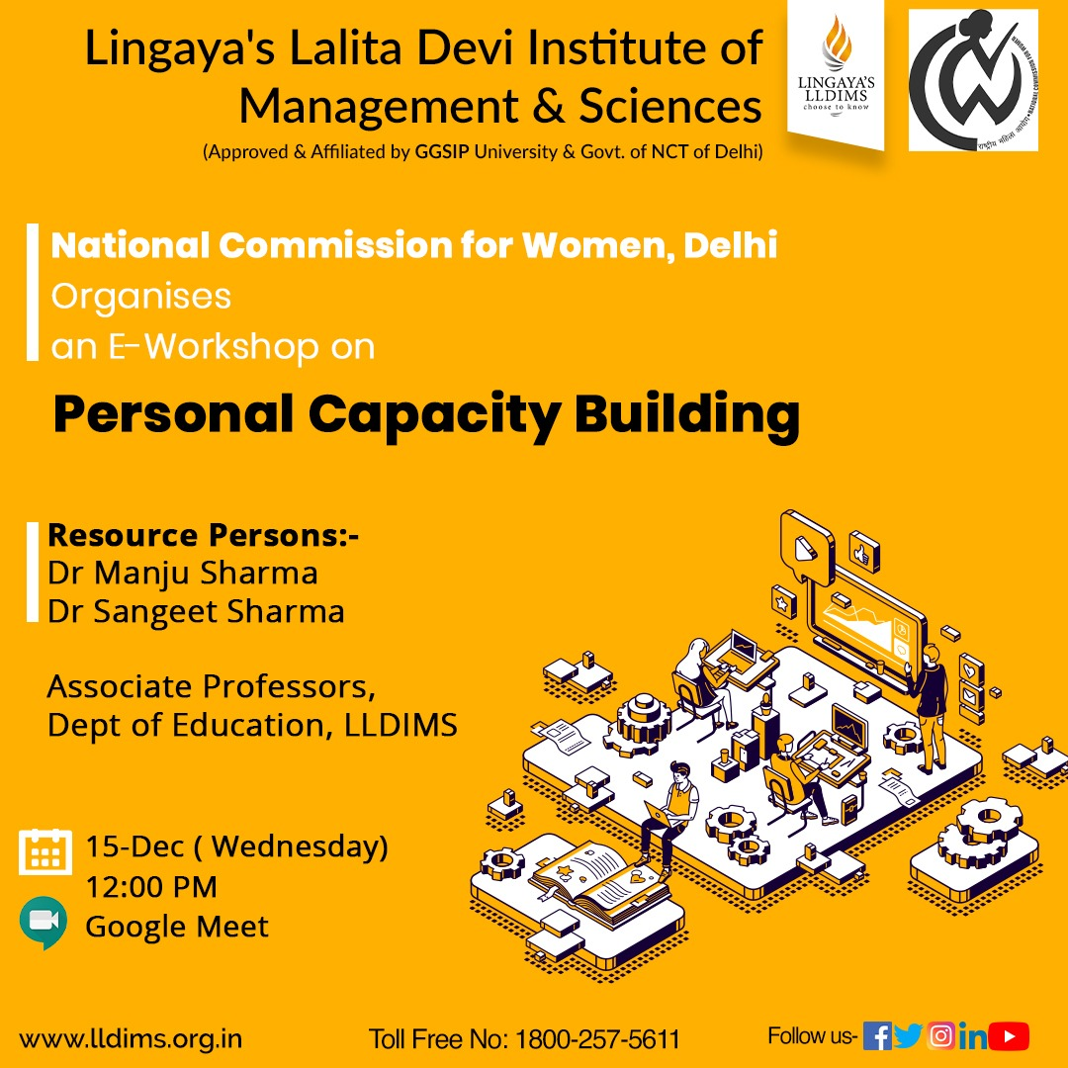
All in all, the E-workshop commenced on a fruitful note and expanded the horizons of each student.
E- WORKSHOP ON “Digital Literacy: – Tools and Techniques” BY NATIONAL COMMISSION OF DELHI
In light of the current challenging times there has been a shift in teaching learning from Information Communication Technology (ICT) supported to ICT integrated, and thus online learning should not be merely regarded as an alternative but as a necessity. In view of this Department Of Education (DOE) organized a one day workshop on the theme “Digital Literacy – Tools and Techniques” on 27th Dec 2021, via Google Meet Video-conferencing virtual platform. It was attended as the most awaited capacity building or skill enhancement opportunity by the pupil teachers, educators and faculties. The workshop began at 10 with a discussion on the relevance of ICT in the contemporary context.
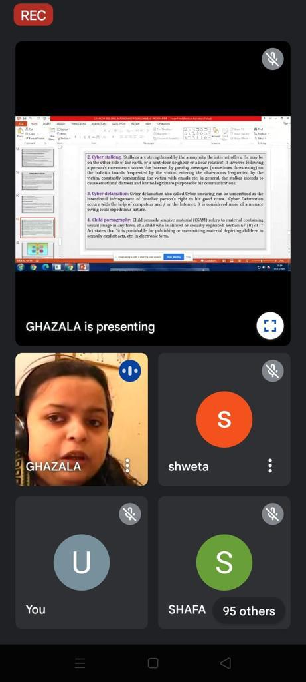

The workshop significantly improved their knowledge on the paradigm change in ICT integrated learning.
Overall, workshop was well received, applauded and had been a rich learning experience for all the participants, who also requested for more such capacity development workshops in future also. Undoubtably, successful facilitators and educators in the future would be digitally literate and ICT skilled.
WEBINAR ON SIMULATION TEACHING
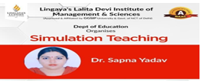
On 22nd February, 2021 Department of Education organised
a one day webinar on the topic- Simulation Teaching by Dr. Sapna Yadav.
She explained that Experiential learning such as simulation has been
promoted as a means to challenge student’s misconceptions.
Experiential learning encourages higher-order learning, which promotes
critical thinking abilities and self-directed learning.
She found that student’s involved in experiential learning have a greater
understanding of their subject matter than students in a traditional
lecture-only class.Students understood the importance of three
elements which are necessary for effective simulations; preparation,
active student participation, and post- simulation debrief.

Workshop ON “ARTS AND CRAFTS AND ITS PEDAGOGICAL SIGNIFICANCE”
The Department of Education conducted a workshop on 27th February, 2021 on ‘Arts and Crafts and its Pedagogical Significance’ for DPSE students.Mr. Anil Sharma explained various methods of art and craft to students. In this workshop students were taught about various paintings and craft methods, tie and dye. Students make various kinds of paintings and learn how to use them in various pedagogies.
